

Manual Testing Interview Questions with Answers

Written by

Ehsanul Alam Sabbir

# 1. What is the Software Development Life Cycle?

SDLC is the overall process of developing information systems through a multistep process from investigation of initial requirements through analysis, planning, design, coding, testing, implementation, and maintenance.

# 

# 2. What are the Phases of SDLC?

1. Requirement gathering and analysis.
2. Design.
3. Implementation or coding.
4. Testing.
5. Deployment.
6. Maintenance.

## I. Initial (or) Requirement phase:

**Tasks:** Interacting with customers and gathering the requirements.

**Roles:** Business analyst –BA, Engagement manager - EM

**Process:**

* First of all business analyst will take an appointment from the customer, collect the template from the

company and meet the customer on the appointed date, gather the requirements with the support of that

template and comes back to the company with the requirement document.

* The engagement manager go through the requirements, if he finds any extra requirements then he will deal

with an excess cost of the project.

* If at all he finds any confusing requirements, then he will ask the concerned team to build a prototype,

demonstrate that prototype to the customer, gather’s the clear requirements and finally hand over the

required documents to the BA

**Proof:** The proof document of the Initial phase is the Requirement’s Document (RD).

These documents are called different names in different companies:

FRS: Functional Requirement Specifications

CRS: Customer (or) Client Requirement Specifications

URS: User Requirement Specifications

BRS: Business Requirement Specifications

BDD: Business Design Document

BD: Business Document

Some companies will maintain two documents. One is for overall business flow information and the second is

detailed functional information, but some companies will maintain both this information’s in a single document.

**Template:** Template is the pre-defined format, which is used for preparing a document very easily and perfectly.

SOFTWARE TEST ENGINEERING PCSR

PC SURENDRA REDDY Page 6

**Prototype:** Prototype is a roughly and rapidly developed model which is used for demonstrating to the client in

order to gather clear requirements and also to build the confidence of a customer.

Ex: PowerPoint slide show

## II. ANALYSIS PHASE:

**Tasks:**

* Feasibility study
* Tentative planning
* Technology selection and Environment confirmation
* Requirement analysis

**Roles:** System Analyst – SA, Project Manager – PM, Technical Manager - TM

**Process:**

a. Feasibility study:

It is a detailed study conducted on the requirement documents, in order to confirm whether the given

requirements are possible within the given budget, time, and available resources or not.

b. Tentative planning:

In this section resource planning and time planning will be temporarily done.

c. Technology selection & Environment confirmation:

The list of all technologies required for accomplishing the project successfully will be analyzed, the environment

suitable for that project will be selected and mentioned here in this section.

d. Requirement analysis:

The list of all the requirements that are required by the company to accomplish this project successfully will be

analyzed and listed out clearly in this section.

**Note:** Requirements may be Human Resources, Software’s, and Hardware.

**Proof:** The proof document of the Analysis phase is System Requirements Specifications (SRS)

## III. DESIGN PHASE:

**Tasks:**

* High-level designing
* Low-level designing

**Roles:**

* High-level design is done by the Chief Architect(CA)
* Low-level design is done by Technical Lead(TL)

**Process:**

* The chief architect will divide the whole project into modules by drawing some diagrams using unified modeling language (UML).
* The Team lead will divide the modules into sub-modules by drawing some diagrams using the same UML.
* In this phase, they will also design the GUI part of the application, as well as PSEUDO CODE also developed

**Proof:** The proof document of this phase is Technical Design Document (TDD).

LLD: Ex: DFD-Data Flow Diagram, E-R Diagram, Class Diagram, Object Diagram.

**PSEUDO CODE:** PSEUDO Code is a set of English instructions, which will make the developer’s more comfortable while developing the actual source code.

## IV. CODING PHASE (WHITE BOX TESTING):

**Tasks:** Programming (or) Coding

**Roles:** Programmers (or) Developers

**Process:** The developers will develop the actual source code by following the coding standards and also with the support of the Technical Design Document.

**Example’s for Coding standards:**

* Proper Indentation (left margin)
* Color codling’s
* Proper Commenting

**Proof:** The proof document of the Coding phase is Source Code Document (SCD)

## V. TESTING PHASE (BLACK-BOX TESTING):

**Tasks:** Testing

**Roles:** Test Engineers.

**Process:**

* The Testing department will receive the requirement document and the test engineers will start

understanding the requirements.

* While understanding the requirements, if they get any doubts they will list out all the doubts in the Requirement clarification Note and send it to the author of the requirement document and wait for the clarification.
* Once the clarification is given and after understanding all the requirements clearly, they will take the test case template and write the Test cases.
* Once the first build is released they will execute the test cases.
* If at all any defects are found they will list out all the defects in the defects profile and send it to the development department and will wait for the next build.
* Once the next build is released they will re-execute the required test cases.
* If at all any more defects are found they will update the defect profile. Send it to the development department and will wait for the next build.
* This Process is continuous till the product is defect-free.

**Proof:** The proof of the Testing phase is a Quality product.

**BUILD**: A finally integrated all modules set. EXE form is called Build

**TEST CASES:** Implementing the creative Ideas of the Test Engineer on the application for testing, with the help of requirement document is known as TEST CASES

## VI. DELIVERY AND MAINTENANCE PHASE:

Delivery:

* Tasks: Hand over the Application to the client
* Roles: Deployment engineers (or) Installation engineers.
* Process: The Deployment engineers will go to the customer’s place, install the application into the customer’s environment and hand over the original software to the client.
* Proof: The final official agreement made between the customer and company is a proof document for Delivery.

Maintenance:

Once the application is delivered. The customer will start using it while using it if at all they face any problems then that particular problem will be created as a task. Based on the tasks corresponding roles will be appointed. They will define the process and solves the problem. This process is known as Normal Maintenance. But some customers may request continuous Maintenance, in that case, a team of members will be continuously working on the client-side in order to take care of their Software.

Where exactly testing comes into the picture?

Which sort of testing we are expecting?

How many sorts of testing are there?

# 3. What are the various models of SDLC?

**Various models of SDLC are:**

1. Waterfall Model (Linear Sequential Model)
2. Prototype Model
3. Rapid Application Development Model
4. Spiral Model
5. V - Model

# 4. What is Waterfall Model?

The **waterfall model** is a sequential design process, in which progress is seen as flowing downwards (like a **waterfall**) through the phases of analysis, design, code, testing, support, and maintenance.

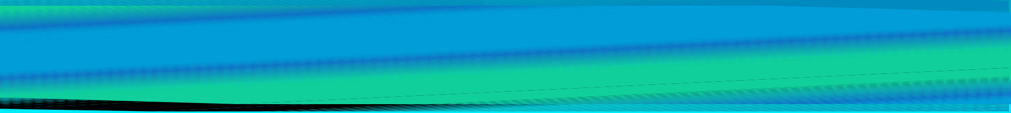

Waterfall Model

**ADVANTAGES:**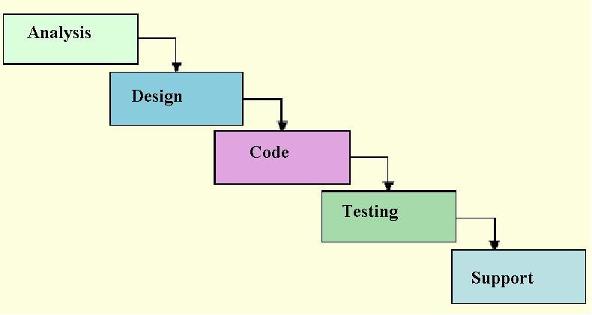

1. It is a simple model.

2. Project monitoring and maintenance is very easy.

**DISADVANTAGES:**

Can’t accept the new requirements in the middle of the process.



# 5. What is Spiral Model?

In Spiral Model, activities are organized into many cycles-

Each cycle begins with the Identification of objectives for that cycle for

* Different alternatives that are possible achieving the objectives
* Constraints that exist
* Different alternatives are evaluated based on the objectives and constraints
* All the products developed during this cycle are reviewed
* Further planning based on user comments is done.

Ex: Risk based scientific projects, Satellite projects.

**ADVANTAGES:**

Whenever the project is highly risk based this is the best suitable model.

**DISADVANTAGES:**

1. Time consuming model.

2. Costly model.

3. Risk route cause analysis is not an easy task.

NOTE: Cycles depend upon Risk involved in the project and size of the project, Every cycle has 4 phases, except the

last phase.



Spiral Model

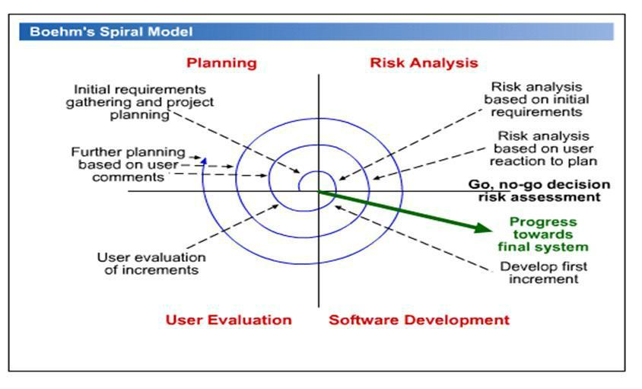



# 6. What is the Rapid Application Development (RAD) Model?

RAD model is a type of incremental model. In the RAD model the components or functions are developed in parallel as if they were mini-projects.

The phases in the RAD model are:

* **Business modeling:** The information flow isidentified between various business functions.
* **Data modeling:** Information gathered frombusiness modeling is used to define data objects that are needed for the business.

Rapid Application Development Model

* Process modeling: Descriptions are created for adding, modifying, deleting or retrieving a data object.
* Application generation: Automated tools are used to convert process models into code and the actual system.

**Testing and turnover:** Test new components andall the interfaces.



Rapid Application Development Model

| **Team #1** | **Team #2** | | **Team #3** | |
| --- | --- | --- | --- | --- |
| **Business** |  | **Business** |  | **Business** |
| **modeling** | **modeling** | |  | **modeling** |
| **Data** |  | **Data** | | **Data** |
| **Modeling** | | **modeling** | | **modeling** |
|  | **Process** |  | **Process** | **Process** |
| **Modeling** | |  | **modeling** | **modeling** |
|  | **Application** |  | **Application** | **Application** |
|  | **Modeling** |  | **Modeling** | **Modeling** |

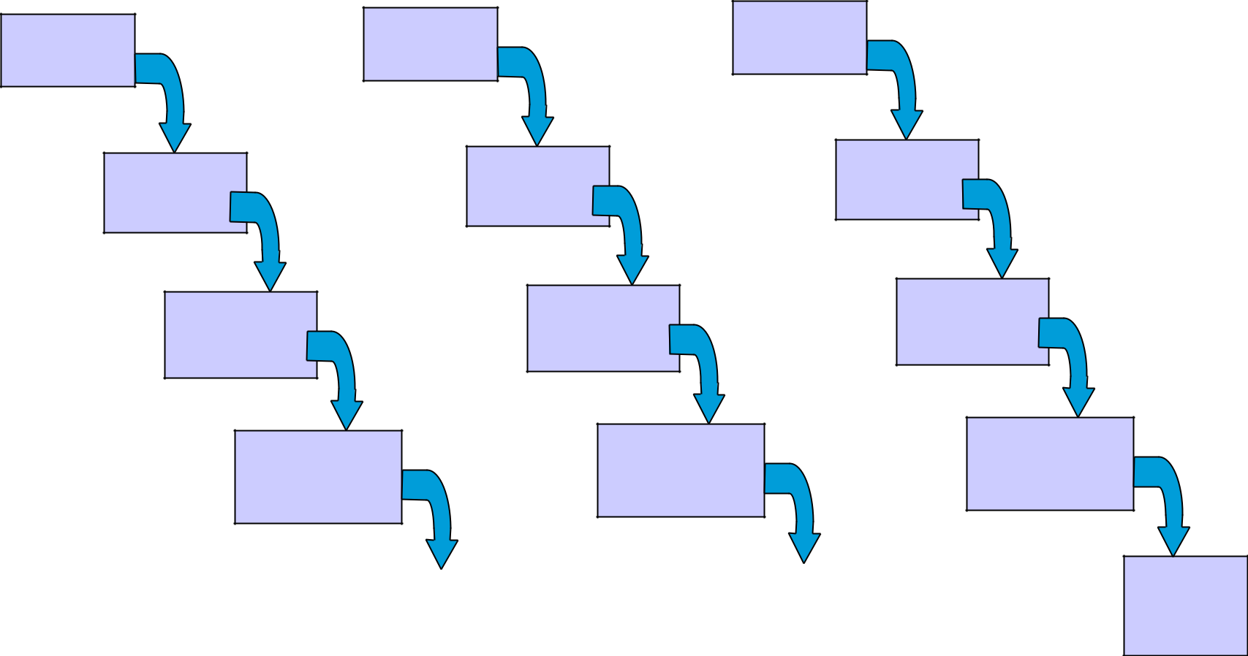

|  |  | **Test and** |
| --- | --- | --- |
| **Test and** |  |
| **turnover** |  | **turnover** |
|  |  |  |
|  |  |  |

# **7. What is V - Model?**

* V- model is also called as Verification and Validation model.
* In V Model, project development and testing should go parallel.
* The verification phase should be carried out from SDLC where the validation phase should be carried out from STLC.

**ADVANTAGES:**

As verification, validation, test management process is maintained. The outcome will be a quality

product.

**DISADVANTAGES:**

1. Time consuming model.

2. Costly model.

**AGILE MODEL:**

Before development of the application, where testers write the test cases and gives to the

development team, so that it can be easy for developers to develop defect free Programs.



V - Model

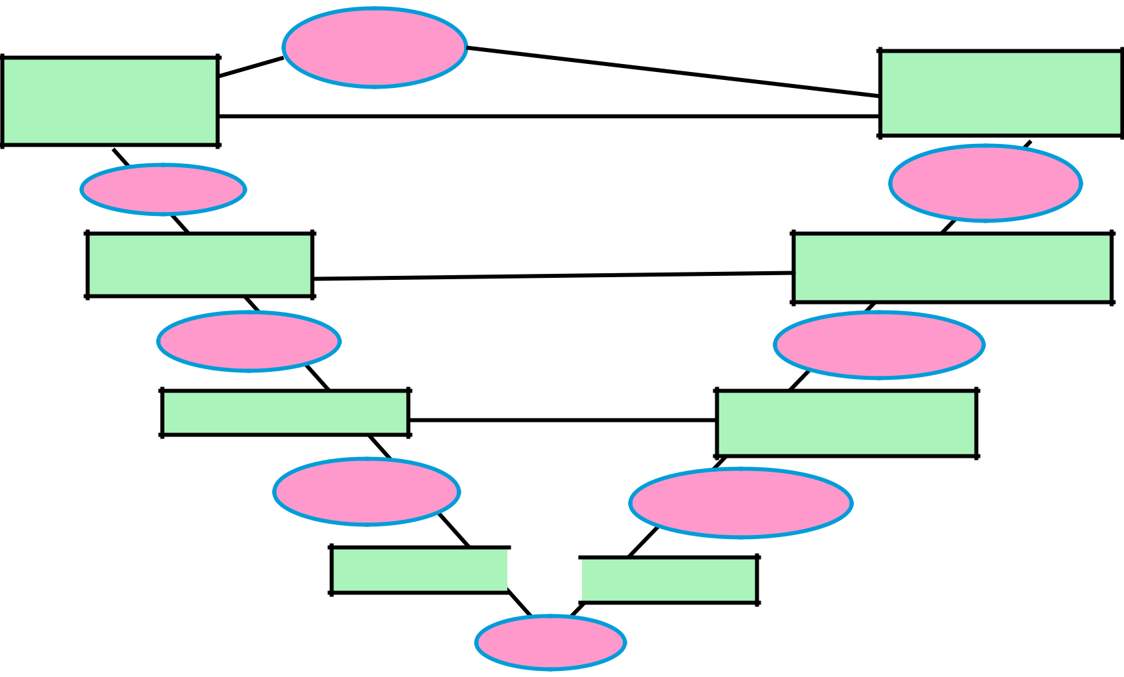

User Manual

Requirement

Specification

SRS

System Design

System

Design

Detailed Design

Module

Designs

Coding

System Test,

Acceptance Test

Tested

Software

System Integration

Test

Integrated

Software

Integration Test

Tested

Module

# 

# 8. Terminology:

IF A DEVELOPER FINDS A MISTAKE IN CODE, WHILE DEVELOPING OF AN APPLICATION IT IS CALLED AN **ERROR**.

IF A TESTER FINDS A MISTAKE IN A BUILD, WHILE TESTING IT IS CALLED A **DEFECT** (or) **ISSUE**.

IF A DEFECT IS ACCEPTED BY DEVELOPER TO SOLVE IT IS CALLED A **BUG**.

IF A CUSTOMER FINDS ANY MISTAKES, WHILE USING THE APPLICATION IT IS CALLED A **MISTAKE** (or) **FAULT** (or) **FAILURE**.

A mistake in code is called **ERROR**.

Due to errors in coding, test engineers are getting mismatches in application called **DEFECTS**.

If defect accepted by development to solve called **BUG**.

* 7. What is Unit Testing?
* This is the first level of testing.
* It involves checking that each feature specified in the ‘Component Design’ has been implemented in the component.

add(x=6,y=8){

Int x

Int y

Result =x+y

Return result

* Developers do it, as they are the people who understand how a component works.

8. What is Integration Testing?

* Tested components are linked together to check if they work with each other
* The tests are organized to check all the interfaces, until all the components have been built and interfaced to each other producing the whole system

9. What is System Testing?

* Once the entire system has been built, it is tested against system specification.

* System testing is not about checking the individual parts of the design, but about checking the system as a whole.

10. What is Acceptance Testing?

●Checks that the system delivers what was requested.

●Acceptance Testing is a level of the software testing where a system is tested for acceptability.

11. What is Verification?

●Verification is the process of confirming that software meets its specification.

●It involves reviews and meetings to evaluate documents, plans, code, requirements and specifications.

12. What is Validation?

●Validation is the process of confirming that software meets the user’s requirements.

●Validation typically involves actual testing and takes place after verifications are completed.

Difference between verification and validation:

Verification:

1. Verification is a static testing technique.

2. Uses methods like reviews, walkthroughs, and inspection.

3. Verification finds the bugs early in the development cycle.

Validation:

1. Validation is a dynamic testing technique.

2. Uses methods like black-box testing, white-box testing, and non-functional testing.

3. Validation finds the bugs that verification cannot catch.

(Guru99)

13. What is Test Scenario?

●Test scenario is prepared before the actual testing starts.

●it includes plans for testing product, number of team members, environmental condition, making test cases, making test plans and all the features that are to be tested for the product

14. What is Test Methodology?

Test methodology is a three step process - ●creating a test strategy,

●creating a test plan, and ●executing tests.

15. What is Test Strategy?

Test strategy documents -

●describes the roles, responsibilities, and resources required for the test and schedule.

●tells us how the software product will be tested.

●helps to review the test plan with the project team members executing tests.

16. What is Test Plan?

Test Plan is a document that describes the scope, approach, resources and schedules of internal testing activities.

17. What is the Requirement Test Matrix?

is a project management tool for tracking and managing testing efforts based on requirements throughout the project lifecycle.

18. What is Test Case?

Test case is a documents which contains set of test inputs, execution conditions, and expected output

19. What is STLC?

Software Testing Life Cycle (STLC) is the testing process, in which different activities are carried out to improve the quality of the product.

Steps in STLC are-

* Requirement Analysis
* Test Planning
* Test Case Development
* Environment Setup
* Test Execution
* Test Cycle Closure

Software Testing Life Cycle(STLC)

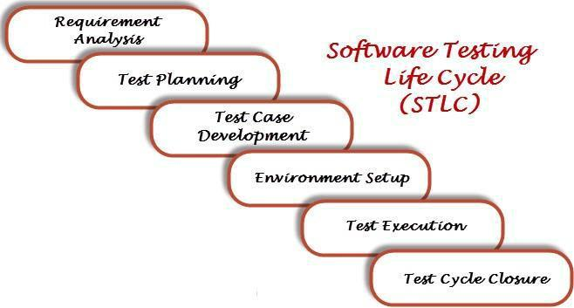

20. What is Bug Life Cycle?

* Bug life cycle, also known as the Defect Life cycle is the journey of a defect cycle, which a defect goes through during its lifetime.
* It starts when defect is found and ends when a defect is closed, after ensuring it’s not reproduced.

21. What is Severity & Priority of a Bug?

**Severity** of a bug is, impact of the bug onthe system.

**Priority** describes the importance andorder in which the bug should be fixed.

22. Low Severity & High Priority Bug?

The spelling mistakes that happens on the cover page or heading or title of an application.

23. High Severity & Low Priority Bug?

application crashes after multiple use of any functionality (example--save Button use 200 times then that application will crash).

24. What is Black Box Testing?

In black-box testing the tester is concentrating on what the software does, not how it does it. tester would know the legal input and expected output.

Black box testing is also known as-Behavioral testing or Functional testing.

25. What is White Box Testing?

White box testing is a testing technique, that examines the program structure and derives test data from the program logic / code.

White box testing is also known as -glass box testing, clear box testing, open box testing, structural testing.

26. What is Grey Box Testing?

Grey box testing is a combination of white box and black box texting.

Grey Box testing is testing technique performed with limited information about the internal functionality of the system.

27. What is Retesting?

Retesting is testing of a particular bug after it has been fixed.

28. What is Regression Testing?

Regression testing is always done to verify that modified code does not break the existing functionality of the application.

29. What is Smoke Testing?

Smoke testing is a cursory testing, it is a shallow and wide approach, whereby all areas of the application is tested, without getting into too deep.

30. What is Sanity Testing?

Sanity testing is a narrow regression testing that focus on one or few areas of functionality, and is usually narrow and deep.

31. What is Error, Fault, Defect?

**Error:** a human action that produces anincorrect result.

**Fault:** manifestation of an error in softwarealso known as a **defect** or **bug** if executed, a fault may cause a failure

32. What is Alpha Testing?

Alpha testing is performed by in-house developers and software quality assurance people.

33. What is Beta Testing?

Beta testing is conducted by the customers in the absence of the developer team.

34. What is Negative & Positive Testing?

Negative Testing:- when we put in an invalid input and receives errors.

Positive Testing:- when we put in a valid input and expect some action to be completed in accordance with the specification.

35. What is Monkey Testing?

**Monkey testing** is a technique where theuser tests system by providing random inputs and checking the behavior, or seeing whether the application or system will crash.

Monkey testing is usually implemented as random, automated unit tests.

36. What is Showstopper Defect?

A defect that does not allow to continue further testing is called a showstopper defect.

37. What is Disaster Recovery Testing?

Disaster Recovery Testing is testing how well the system recovers from the disasters, crashes, hardware failures and other catastrophic problems.

38. What is Performance Testing?

Performance Testing is performed to evaluate application performance under high load and stress condition.

It is generally measured in terms of response time for the user activity.

39. What is Load Testing?

Testing of an application under heavy loads, such as testing of a web site on a specific configuration under a range of loads such as number of users, number of transactions to determine at what point the system's response time degrades or fails.

40. What is Stress Testing?

Stress testing is performed as part of performance testing.

Stress testing is, to test the system behavior under extreme/non-normal conditions (low system resources, heavy load…).

41. What is Exploratory Testing?

* Exploratory testing means testing an application without a test plan and test script.
* In exploring testing test explore the application on the basis on his knowledge. The tester has no knowledge about the application previously.
* Tester explores the application like an end user and try to use it. While using the application his main motive is to find the bugs which are in the application.

42. What is Database Testing?

Database testing involves the retrieved values from the database by the web or desktop application.

Data in the User Interface should be matched as per the records are stored in the database.



1. What is Different Black Box Test case Design Techniques?

The different black box test case design techniques are :

* Equivalence Class Partitioning(ECP).
* Boundary Value Analysis(BVA).()
* Decision Table.
* State Transition Testing
* Use Case Testing

44. What are Stubs & Drivers?

* Both stubs and drivers are part of incremental testing.
* Drivers are used in bottom up testing approach
* While Stub is used for top down testing approach.



1. What are the different types of test coverage techniques?

Different types of test coverage techniques are :-

* **Statement Coverage:** It verifies that each line ofsource code has been executed and tested.
* **Decision Coverage:** It ensures that everydecision in the source code is executed and tested.
* **Path Coverage:** It ensures that every possibleroute through a given part of code is executed and tested.



* 1. What is the difference between build and release?
* **Build:** It is a number given to Installable softwarethat is given to testing team by the development team.
* **Release:** It is a number given to Installablesoftware that is handed over to customer by the tester or developer**.**



1. what is the meaning of Code Walk Through?

Code Walk Through is the informal analysis of the program source code to find defects and verify coding techniques



* 1. What is Agile testing and what is the importance of Agile testing?
* Agile testing is software testing, which involves the testing of the software from the customer point of view.
* **importance of Agile testing -** this testing doesnot wait for development team to complete the coding first and then doing testing. The coding and testing both goes simultaneously. It requires continuous customer interaction**.**

49. What is "use case testing"?

In order to identify and execute the functional requirement of an application from start to finish "use case" is used and the techniques used to do this is known as "Use Case Testing"

50. What is the purpose of exit criteria?

The purpose of exit criteria is to define when a test level is completed.

OSI model

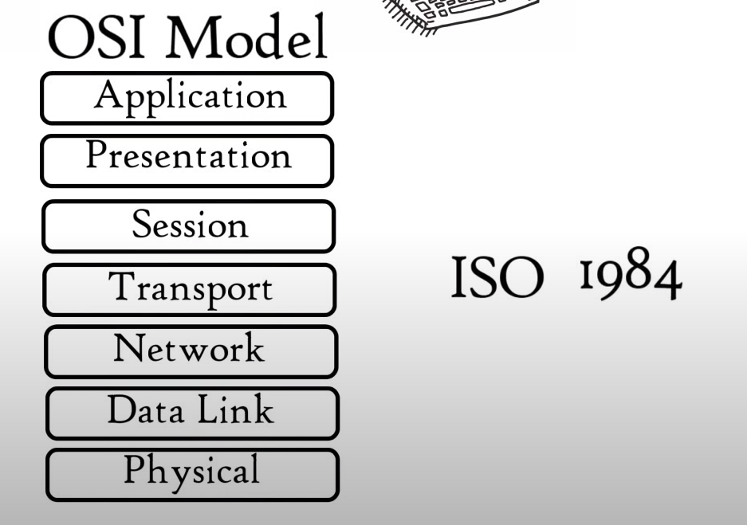

1. Protocols under application layer

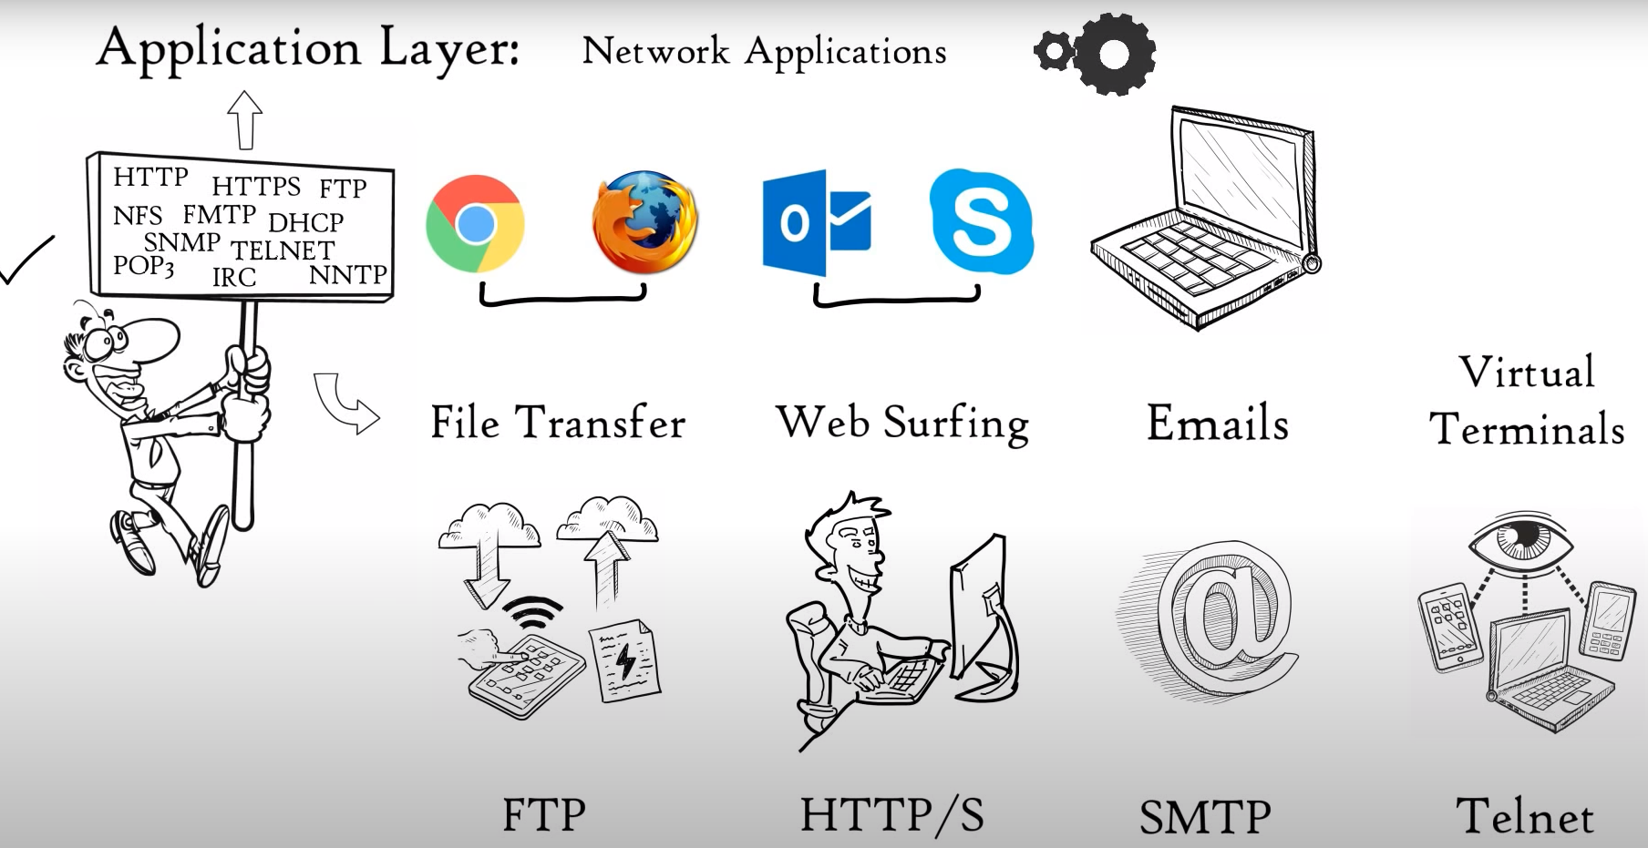

File transfer protocol: FTP

Web surfing: HTTP / HTTPS

Email : SMTP

Virtual Terminal: Telnet

1. Protocols under presentation layer :

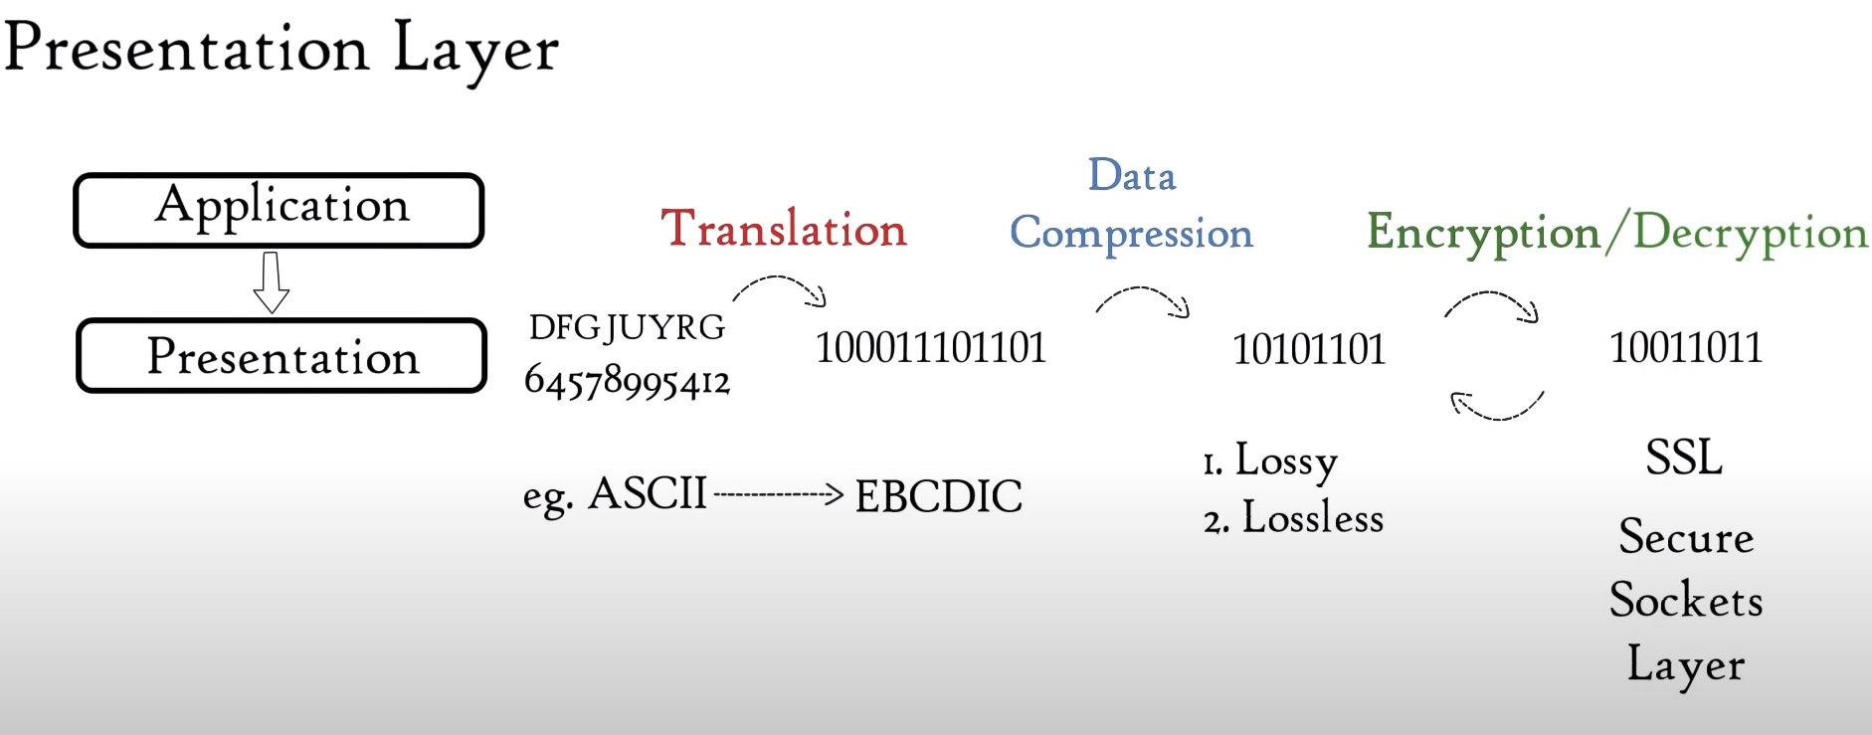

Encryption using SSL: Secure sockets layer

Compression is done in this layer and good for video and audio transmission

Three task: Translation → Data compression → Encryption/Decryption

1. Session Layer:

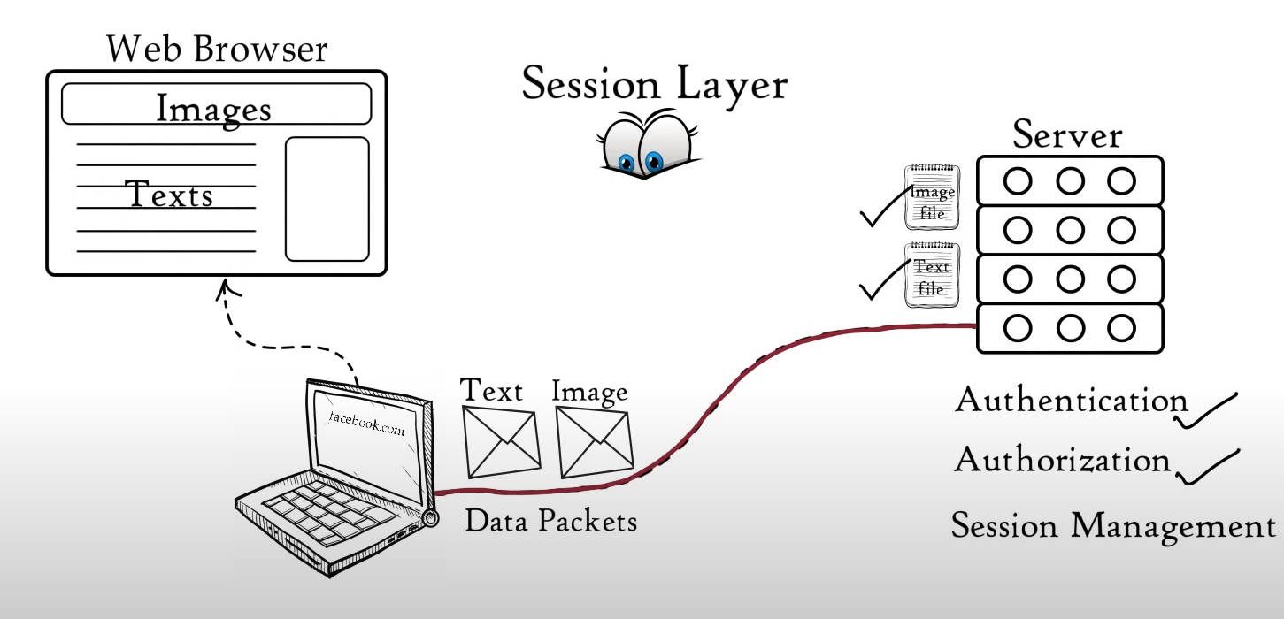

Authentication: username/password,

Authorization : Accessing pages

Session Management

API’s

NETBIOS

Data packets arrangement

1. Transport Layer: 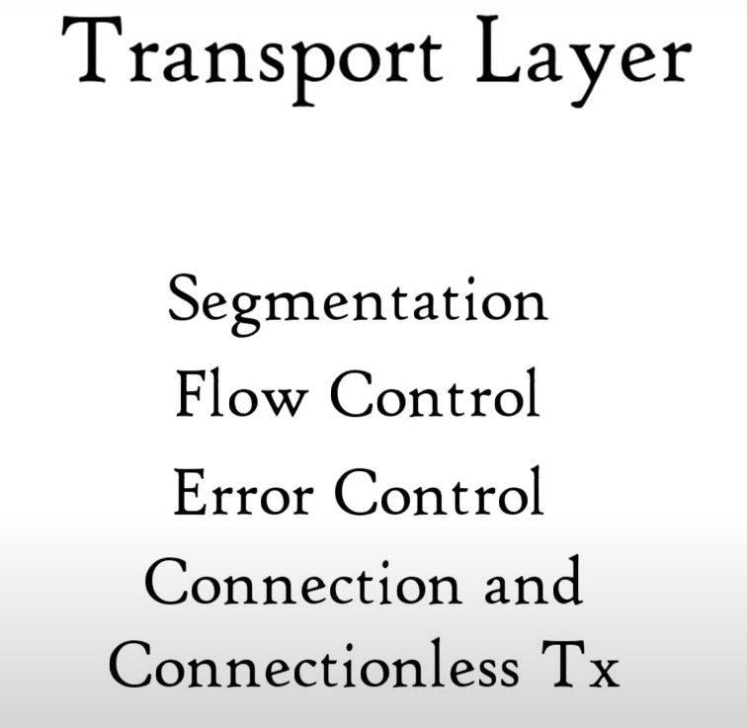

Segmentation

Flow control

Error Control

Protocols:

1. TCP-> Transmission Control Protocol -> Connection oriented transmission
2. UDP -> User Datagram Protocol -> Connectionless Transmission

UDP faster because no feedback : Used in online streaming, songs , movies

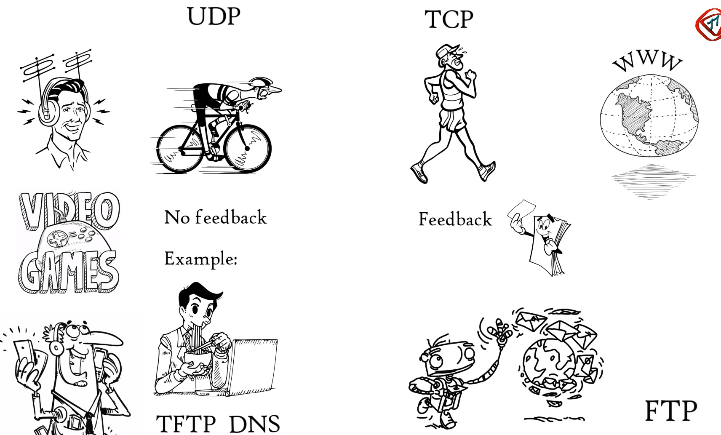

5. Network Layer

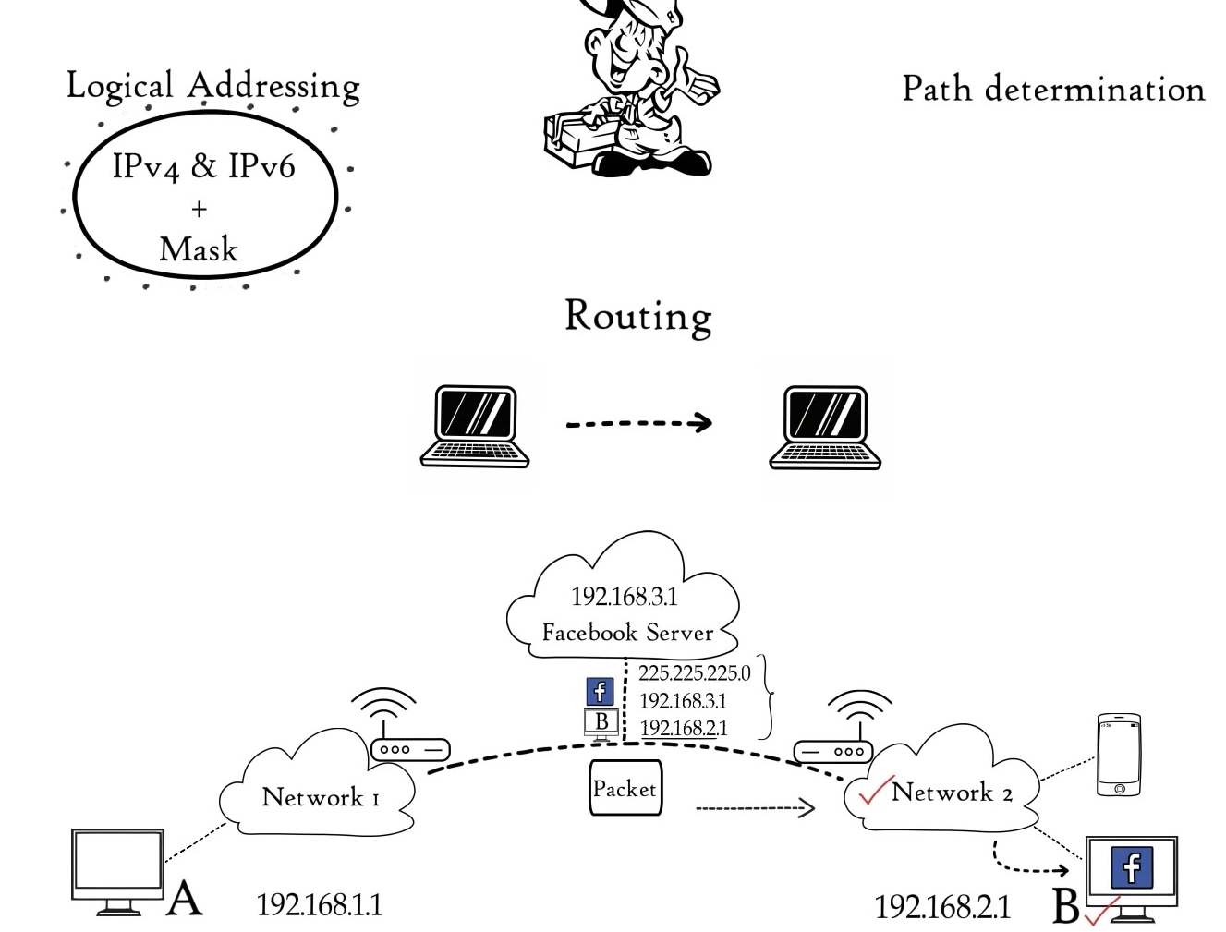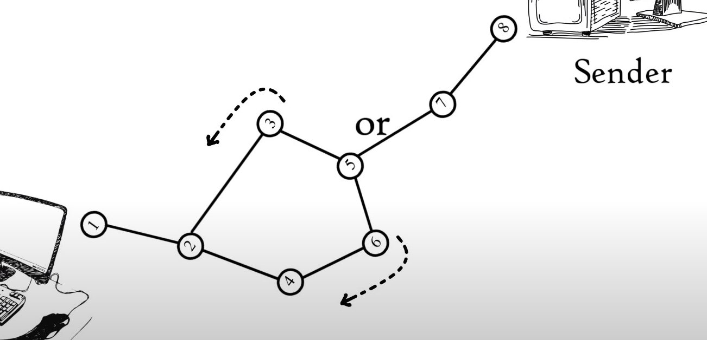

**Logical Addressing:** IPv4 and IPv6

path determination protocol:

OSPF: Open shortest path first,

BGP-Border gategay protocol,

IS-IS: Intermediate system to intermediate system.

6. Data Link Layer

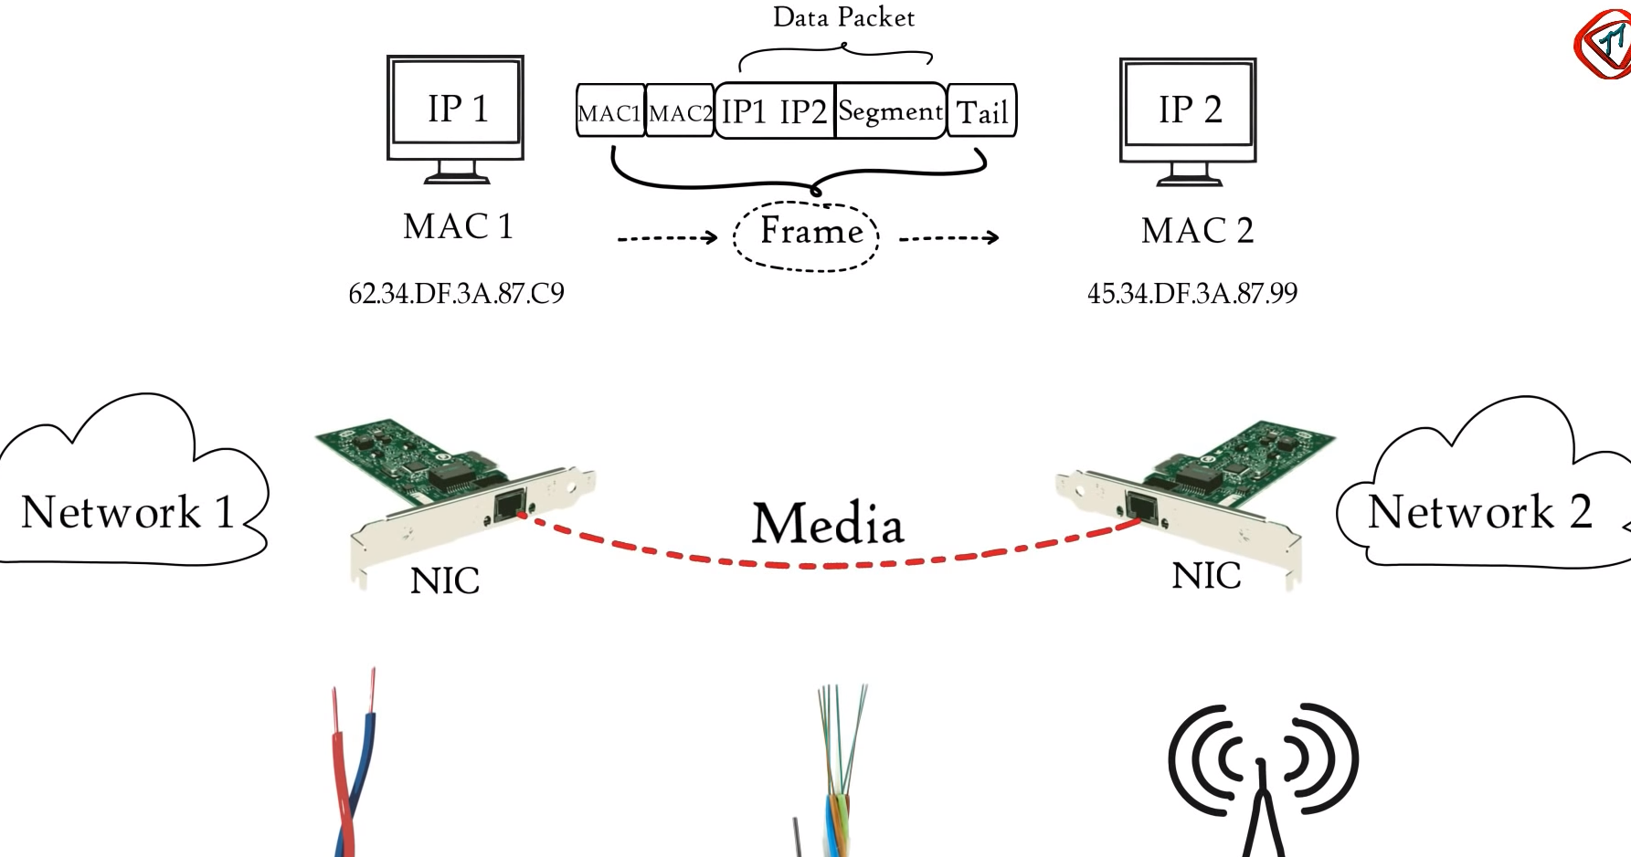

7. Physical Layer

